PROECT REPORT

**1. INTRODUCTION**

1.1 OVERVIEW

Building an event management system using Salesforce involves designing and implementing a comprehensive solution that enables event planners to manage various aspects of their events, such as attendees, ticketing, venue, and schedule. In this project report, I will outline the steps involved in building such a system using Salesforce.

1. Requirements gathering: The first step in building an event management system is to gather requirements from the stakeholders. This includes identifying the features and functionalities that the system should have, such as event registration, ticketing, payment processing, scheduling, and attendee management.
2. Design: Once the requirements are gathered, the next step is to design the system. This includes creating an entity-relationship diagram (ERD) to model the database schema, designing the user interface (UI) for the system, and identifying the necessary integrations with third-party systems such as payment gateways and email providers.
3. Configuration: After the design is finalized, the system can be configured in Salesforce. This includes creating custom objects and fields, defining validation rules and workflows, and setting up security and access controls.
4. Development: The next step is to develop custom code and integrations to implement the system's features and functionalities. This includes creating Apex classes and triggers, developing Visualforce pages and Lightning components, and integrating with third-party APIs.
5. Testing: Once the development is complete, the system must be thoroughly tested to ensure that it meets the requirements and works as expected. This includes functional testing, performance testing, and user acceptance testing.
6. Deployment: After the system is tested and approved, it can be deployed to production. This includes migrating data from the testing environment to the production environment and training the users on how to use the system.
7. Maintenance: Finally, the system must be maintained and updated over time to ensure that it continues to meet the evolving needs of the stakeholders. This includes monitoring the system's performance, fixing bugs and issues, and adding new features and functionalities.

In summary, building an event management system using Salesforce involves gathering requirements, designing the system, configuring Salesforce, developing custom code and integrations, testing the system, deploying it to production, and maintaining it over time. By following these steps, event planners can leverage Salesforce to create a comprehensive system that streamlines their event management processes and enhances the attendee experience.

1.2 Purpose

The purpose of building an event management system using Salesforce is to provide event planners with a comprehensive and efficient solution to manage all aspects of their events. With this system, event planners can streamline their processes, improve attendee experience, and reduce the likelihood of errors and oversights.

By leveraging the capabilities of Salesforce, such as custom objects, workflows, and integrations with third-party systems, event planners can create a system that is tailored to their specific needs and requirements. The system can automate many of the manual tasks involved in event management, such as attendee registration and payment processing, freeing up event planners to focus on other aspects of the event.

Overall, the purpose of building an event management system using Salesforce is to provide event planners with a powerful tool that enables them to create successful events that meet the needs and expectations of their attendees.

**2. Problem definition and design thinking**

2.1 Empathy map

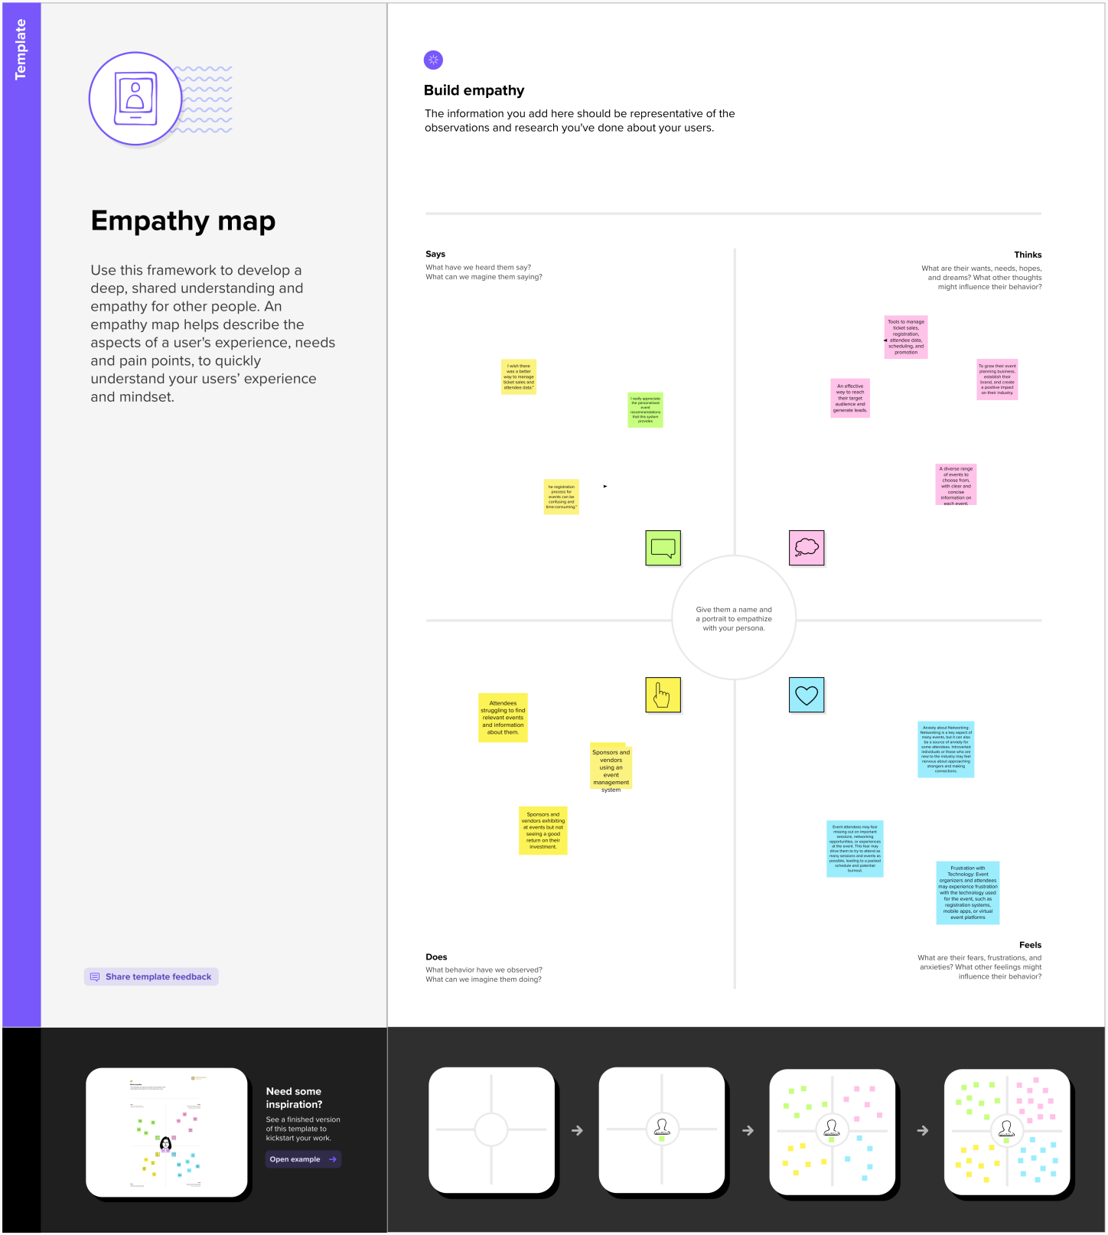

2.2 Ideation & Brainstroming Map

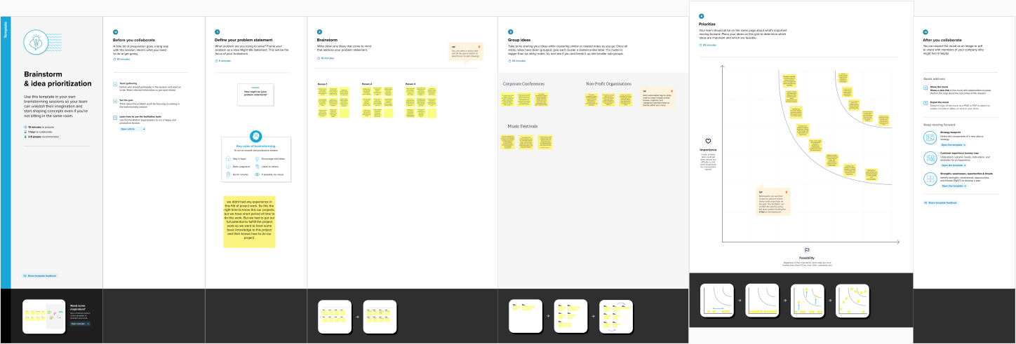

**3 RESULT**

3.1 Data Model:

|  |  |  |  |  |  |  |  |  |  |  |  |  |  |  |  |  |  |
| --- | --- | --- | --- | --- | --- | --- | --- | --- | --- | --- | --- | --- | --- | --- | --- | --- | --- |
| Attendee | |  |  | | --- | --- | | Field label | Data type | | Attendee Name | Text(80) | | Created by | Lookup(user) | | email | Email | | id | Auto Number | | Last modified by | Lookup(user) | | owner | Lookup(user,Group) | | phone | Phone | |
| Event | |  |  | | --- | --- | | Field label | Data type | | Attendee | Master-Detail (Attendee) | | City | Text(10) | | Created by | Lookup(user) | | Email | Email | | Event name | Text(80) | | Id | Auto Number | | Last Modified by | Lookup(user) | | Phone | Phone | | Start date | Date/Time | |
| Vendor | |  |  | | --- | --- | | Field label | Data type | | Created By | Looup(user) | | e-mail | Email | | Event name | Lookup(event) | | Last Modified By | Lookup(User) | | Owner | Lookup(User,Group) | | Phone | Phone | | Service provider | Text(1) | | Vendor Name | Text(80) | |
| Speaker | |  |  | | --- | --- | | Field Label | Data type | | Bio | Text Area(255) | | Created By | Lookup(user) | | E-mail | Email | | Event name | Lookup(event) | | Last Modified by | Lookup(User) | | Owner | Lookup(User,group) | | Speaker Name | Text(80) | |

3.2 Activity & Screenshot

**Event**

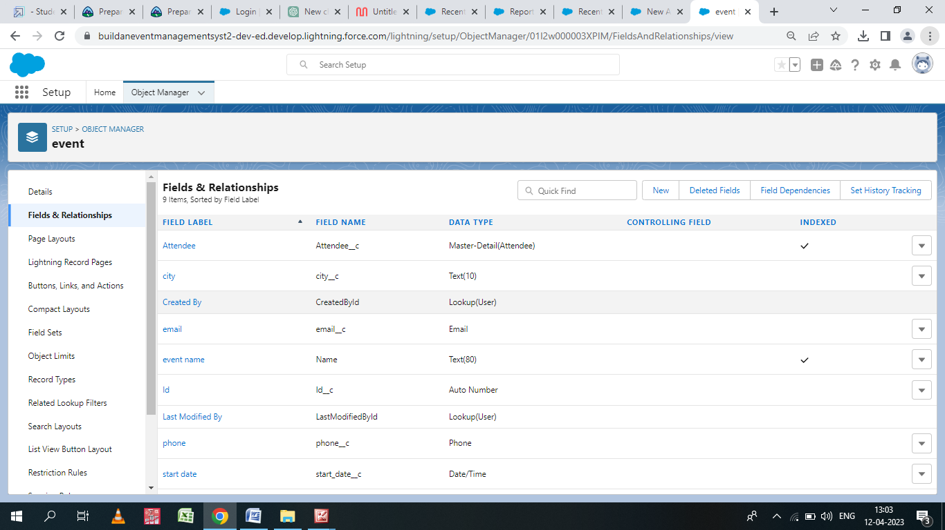

**Speaker**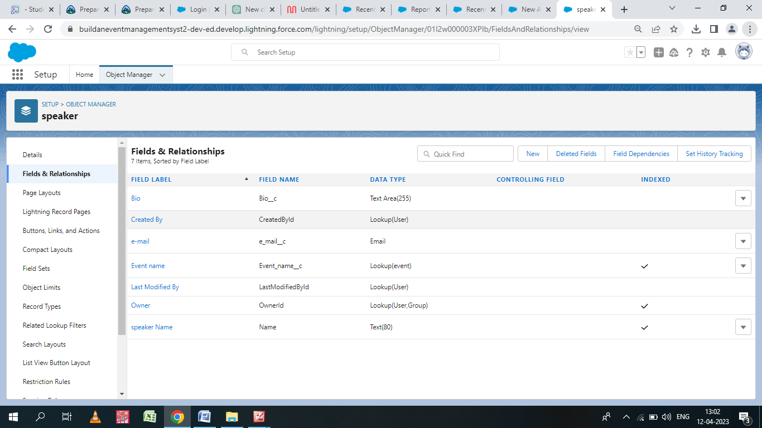

**Attendee**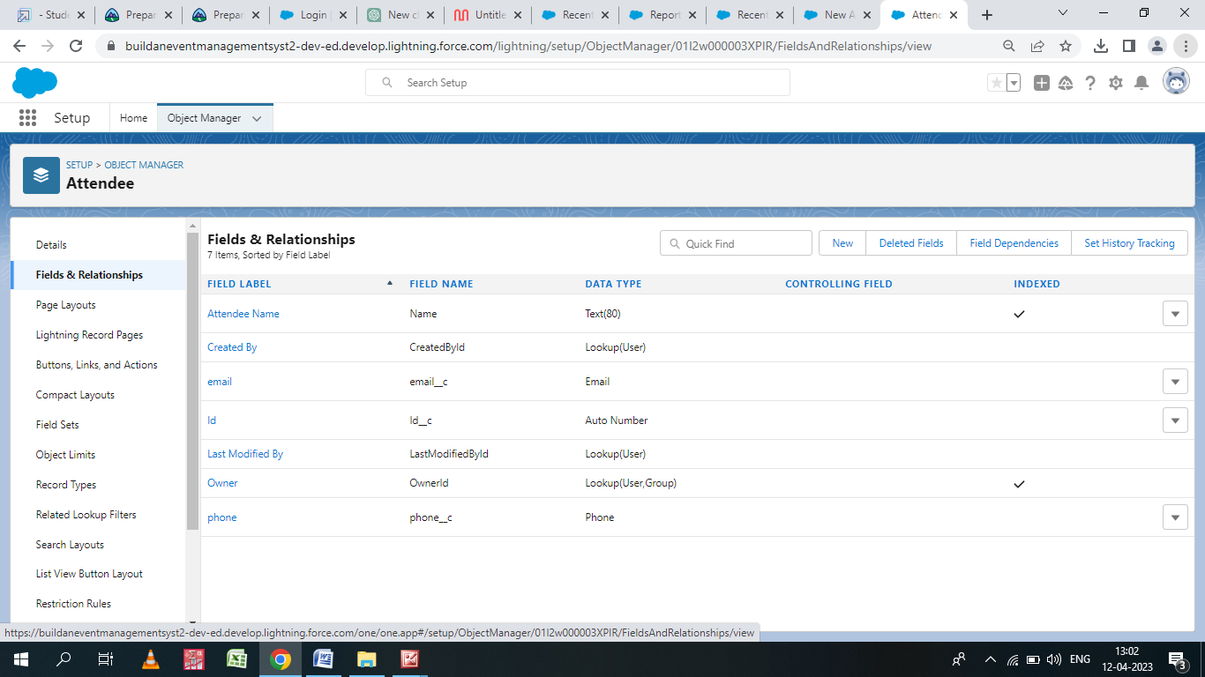

**Vendor**

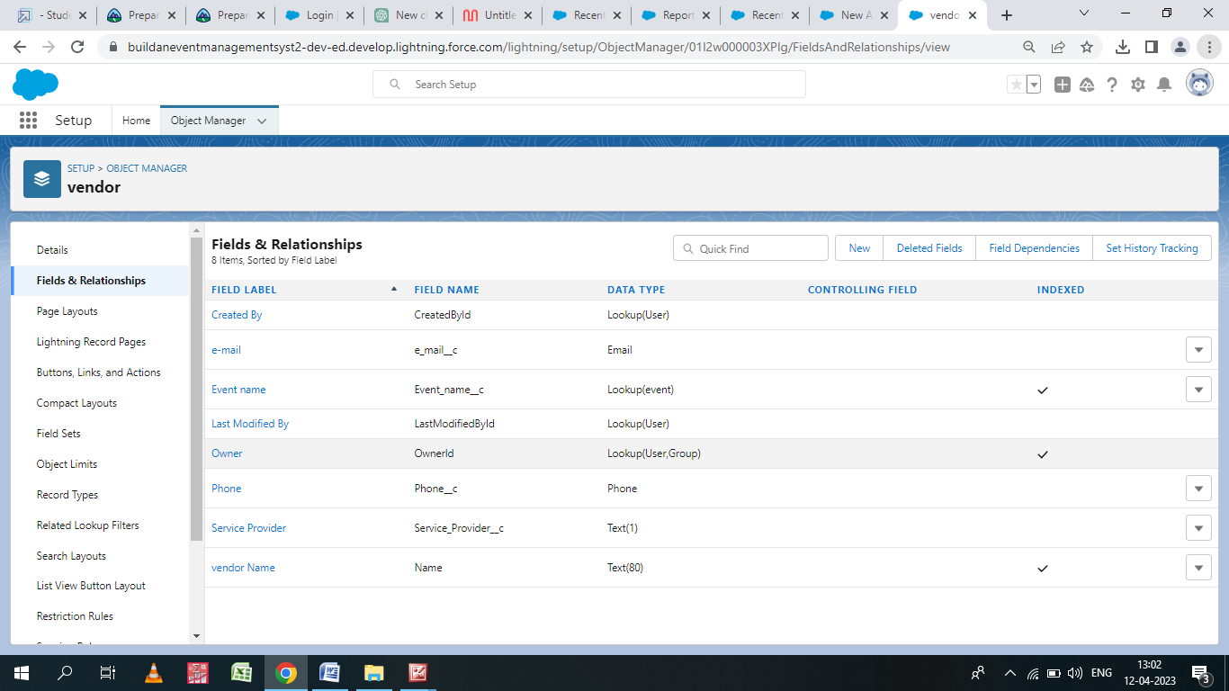

Trailhead Profile Public URL

##### Team Lead – <https://trailblazer.me/id/kkishore104>

##### Team Member 1- <https://trailblazer.me/id/traiblazerravichandiran>

##### Team Member 2[- https://trailblazer.me/id/gchinnu4](-%20https:/trailblazer.me/id/gchinnu4)

# Project Respect Template

###### ADVANTAGES & DISADVANTAGES

# ADVANTAGES

1. Centralized system: Salesforce event management system provides a centralized platform to manage all aspects of events. This allows for better coordination and communication between event teams and departments.
2. Customization: Salesforce is highly customizable, allowing event planners to create tailored event workflows, track event progress, and generate custom reports.
3. Scalability: Salesforce is scalable, meaning it can accommodate events of various sizes and complexity. This makes it a suitable platform for businesses of all sizes and industries.

# DISADVANTAGES

1. Cost: Saleforce event management system can be costly, especially for small businesses or events with a limited budget.
2. Complexity: The platform Is complex and requires training and expertise to use effectively. Event planners may need to invest time and resources in learning how to use the system.
3. Dependence on Internet: Salesforce is a cloud-based platform, which means it relies on internet connectrivity to function. This may cause issues in areas with poor connectivity.

# APPLICATIONS

1. Venue and Logistics Management: Salesforce can be used to manage venue bookings and logistics for events, including room setup, catering, and AV requirements. By creating custom objects and fields to track venue and logistics information, event organizers can easily manage these aspects of events in one central location.
2. Event Marketing and Communications: Salesforce can be used to manage event marketing and communications, including email campaigns, social media outreach, and event-specific landing pages. By integrating with marketing automation tools and creating custom objects and fields to track communication history, event organizers can effectively promote events and engage attendees.
3. Sponsor and Exhibitor Management: Salesforce can be used to manage sponsors and exhibitors for events, including sponsorship agreements, booth assignments, and lead tracking. By creating custom objects and fields to track sponsor and exhibitor information, event organizers can easily manage these relationships and measure ROI.

# CONCLUSION

1. Salesforce can be used to manage the entire event lifecycle, from registration to post-event follow-up.
2. Customization is key, as event planners can create custom objects, fields, and pages to fit their unique event management processes.
3. Integrations with third-party tools, such as payment gateways and marketing automation

# FUTURE SCOPE

1. Artificial Intelligence (AI) Integration: As AI becomes more prevalent in event management, there is scope for integrating AI with Salesforce to enhance event planning and management. For example, AI-powered chatbots could be used to assist attendees with registration and event information, while AI analytics could help event planners analyze attendee data and behavior to improve event outcomes.
2. Virtual and Hybrid Event Management: With the rise of virtual and hybrid events, there is scope for using Salesforce to manage these types of events. Salesforce could be used to manage virtual event registrations, sponsorships, and sessions, as well as hybrid event logistics such as venue bookings and attendee tracking.
3. Mobile App Integration: Many attendees use mobile apps to access event information, engage with speakers, and connect with other attendees. Salesforce could be integrated with mobile event apps to provide real-time updates on event schedules, sessions, and other details.